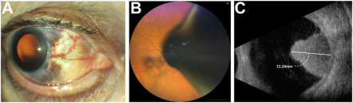

A 70-year-old man presented with decreased vision in the left eye. The examination revealed diffuse blue changes to the left sclera,patches of hyperpigmentation, and large conjunctival vessels in the nasal quadrant (A). Additionally, a pigmented intraocular mass abuttingthe lens (B) was seen nasally. Ultrasound biomicroscopy and B-scan ultrasonography (C) confirmed a ciliary body mass. The blue scleralpigmentation was present since birth; he had no other skin findings. .Based on the provided images and clinical description please make an ophthalmic diagnosis for this patient. And output the diagnostic conclusions only.

**Ocular Melanocytosis with ciliary body melanoma**